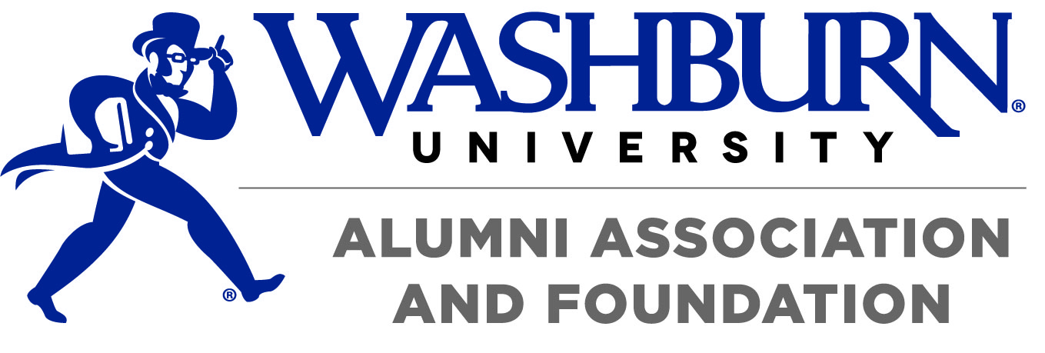
Please return this form by scanning and emailing to ahughes@wualumni.org
Or mail to 1700 SW Jewell Ave., Topeka, KS 66621
A signed copy will be returned to you. Thank you.
Business discount agreement
Responsibilities of the Washburn Alumni Association (WAA):  - Include the name of your business as it appears above, in appropriate membership and marketing materials  - List participating businesses at booths and events where the membership program is promoted.  - List the business as it appears above on the WAA website.  - Provide “More Bod for Your Buck” decals to business owner to post in window and/or near cash register  *Contact Amanda Hughes, assistant director of membership and outreach, at 785-670-1825 or ahughes@wualumni.org if you have any questions. | Responsibilities of the Business Partner:  - Honor the specified discount throughout the agreed upon year, whenever the alumni association member presents his/her valid membership card.  - Verify the membership expiration date listed on the individual’s membership card when presented.  - Post a “More Bod for Your Buck” discount program decal in business window and/or near cash register.  - Notify all employees of the discount.  - Please communicate any change to the WAA as quickly as possible.

Name of Business (as it should appear on promotional materials):
__________________________________________________________________________________________
Business Contact Person: _____________________________________________________________________
Business Address: ___________________________________________________________________________
City, State, Zip: _____________________________________________________________________________
Business Telephone Number: __________________________________________________________________
Contact Person E-mail (preferred method of communication):_______________________________________
Business Website:___________________________________________________________________________
⇧ We will provide a link from the Alumni Association website to your site. All participating businesses are listed on our discount page.
 Yes! I would like to participate in the Washburn Alumni Association Discount Program
I would like to provide the following member only benefit or discount (This discount is valid until December 31, 2019.)
If this discount is for a percentage off it must be 10% or greater). List discount with any restrictions below:
___________________________________________________________________________________________________
 Online coupon code / discount code (if applicable): _________________________________________________
 I would like to support the Washburn Alumni Association by providing printed coupons (Expiration
date must be December 31, 2019 or after. Alumni Association staff member will schedule pick up.)

________________________________________________________________ Date: ___________________
Manager/Owner Signature
________________________________________________________________ Date: ___________________

